УДК: 614.446.1
DOI https://doi.org/10.14258/zosh(2020)3.1

Поведенческая модель во время пандемии (Covid-19) на основе анкетного опроса студентов из Mедицинского университета Болгарии

Танева Светлана Йорданова ^{ABCD}
Старший преподаватель, Факультет общественного здоровья. Медицинский университет. София, Болгария. ORCID: https://orcid.org/0000-0002-1348-0029.
E-mail:svetlanataneva@abv.bg

Behavioral model during pandemic (Covid-19) based on a student survey from Sofia Medical University

Taneva Svetlana Yordanova ^{ABCD}
Senior Lecturer, Faculty of Public Health. Medical University. Sofia, Bulgaria.
ORCID: https://orcid.org/0000-0002-1348-0029. E-mail:svetlanataneva@abv.bg

Следует цитировать / Citation:
Танеева С.Й. Поведенческая модель во время пандемии (Covid-19) на основе анкетного опроса студентов из Mедицинского университета Болгарии // Здоровье человека, теория и методика физической культуры и спорта. 2020. 3 (19), С. 4-16 URL: http://journal.asu.ru/zosh/issue/archive. DOI https://doi.org/10.14258/zosh(2020)3.1
Taneva S.Y. Behavioral model during pandemic (Covid-19) based on a student survey from student survey from Sofia Medical University (2020). Developing Taekwondo flexibility for 10-12 years at the training stage of preparation, with the use of special exercises zhougun. Health, Physical Culture and Sports, 3 (19), 4-16 (in Russian). Available from: http://journal.asu.ru/zosh. DOI https://doi.org/10.14258/zosh(2020)3.1
Поступило в редакцию / Submitted 03.05.2020
Принято к публикации / Accepted 12.06.2020

Аннотация. Цель работы: проанализировать, как чрезвычайная ситуация (Covid-19) влияет на психику, нравственность, привычки питания и занятия спортом студентов (Медицинский университет, София, Болгария) и создать единую конструктивную модель поведения во время пандемии. Материал и методы исследования. Был разработан анкетный опрос с 15 вопросами. Он проводился онлайн во время дистанционного обучения в течение летнего семестра, 2019/2020, с участием болгарских и иностранных студентов, обучающихся по специальностям Медицина и Дентальная медицина в Медицинском университете - София, Болгария. Общее число респондентов, принимающих участие в текущем опросе, составляет 112. Результаты исследования. Исследование показало, что высокий процент участников информируются ежедневно о Covid-19 ситуации, строго соблюдают меры предосторожности и мониторуют изменения в себе. Здоровье - психологическое и физическое, семейная забота, солидарность и лояльность обществу являются приоритетными. Выводы.Следующие эффективные стратегии были определены на том, как заботиться о физическом, психическом и моральном здоровье во время пандемии (Covid-19). 1. Физическое здоровье - поддержание общего образа жизни с незначительными изменениями (экологически сбалансированное питание с акцентом на специфические белки, фрукты и овощи, умеренное количество пищи, общепринятая норма потребления жидкости, регулярные физические упражнения). 2. Психическое здоровье - оставаться психически уравновешенным; высокая степень социальной эмпатии (быть в курсе Covid-19, строгое соблюдение введенных мер безопасности, соблюдение личной, социальной и виртуальной гигиены, личный вклад - работа в качестве волонтера или медсестры, солидарность с сообществом, поддержка и забота о жизни других людей. 3. Моральное здоровье - переоценка существующей системы ценностей, выявляя семейные отношения в качестве приоритета; позитивное отношение к жизни и исходу нынешней пандемии. Изложенная модель поведения Covid-19 должна быть дополнена ответственностью каждого человека за свое физическое, психологическое, социальное и моральное здоровье. Внедрение конструктивного поведения Covid-19 в настоящее время несомненно приведет к контролю сегодняшней пандемической ситуации.

Ключевые слова: анкетный опрос студентов, поведенческая модель Covid-19, пандемия, физическое здоровье, психическое здоровье, моральное здоровье.

Annotation. Objective: to analyze how an emergency situation (Covid-19) affects psyche, morality, eating habits and sports activities of students (Medical University, Sofia, Bulgaria) and create a unified constructive behavioral model during pandemic. Material and research methods. A survey with 15 questions was developed. It was conducted online in times of distance learning during the summer semester of teaching, 2019/2020, with Bulgarian and foreign students, being taught in specialties Medicine and Dental Medicine at the Medical University – Sofia, Bulgaria. The total number of respondents taking part in the current survey is 112. The results of the study. The survey showed that a high percentage of participants are informed daily about Covid-19 situation, strictly observe the precautions and monitor changes in themselves. Health - psychological and physical, family care, solidarity and loyalty to society are prioritized. Conclusions. The following effective strategies have been determined on how to take care of physical, mental and moral health during pandemic (Covid-19). 1. Physical health - keeping overall lifestyle with slight changes (environmentally balanced diet with emphasis in nutrition on specific proteins, fruits and vegetables, moderate amount of food, generally accepted norm of liquid intake, regular physical exercises). 2. Mental health - staying mentally balanced; indicating a high degree of social empathy (staying relevantly informed of Covid-19, strict compliance with imposed safety measures, keeping personal, social and virtual hygiene, personal contribution - working as a volunteer or a nurse, staying in solidarity with community, showing support and loyalty and taking care of other people’s life). 3. Moral health - reassessment of the existing value system, prioritizing family relationships; a positive attitude towards life and outcome of the current pandemic. The outlined behavioral model Covid-19 should be supplemented with the responsibility of each individual to his/her physical, psychological, social and moral health. Implementing Covid-19 constructive behavior at present would definitely lead to control of today's pandemic situation.

Key words: student survey, behavioral model Covid-19, pandemic, physical health, mental health, moral health.

Introduction.
March 13th, 2020 – date on which the deputies of Bulgarian Parliament voted unanimously on the introduction of a state of emergency in the country due to the growing threat of a global pandemic - COVID-19. It was initially announced for a period of one month - from March 13th to April 13th, after which it was extended until May 13th, 2020. State of emergency is a situation in which the government of a country has the power to carry out actions that would not normally have occurred under normal circumstances. The Government may declare such a position on three occasions: during a disaster, civil disobedience or armed conflict. The purpose of introducing such a state of emergency in the particular situation is firstly, warning citizens, and secondly, triggering the mechanism of government services to begin implementing plans for dealing with Covid-19 pandemic.
In a very short period of time, all sectors: medical, social, economic, educational, cultural have focused their efforts on overcoming the pandemic. Experts have joined efforts and, based on scientific research and evidence, are incessantly publishing recommendations for the best protection against the virus. The most important of those are compliance with social and personal hygiene, strengthening body's immune response by means of balanced diet, physical activity and mental health care. The main objective is to create a constructive behavioral model that would gain sufficient time for a quick study of Corona virus by unprecedented scientific data sharing, establishment of an adequate model of treatment and creation of a vaccine that would stop the process of vulnerability to Covid-19 (Tashkova, 2020).
The present research is related to a survey among Bulgarian and foreign students, who are being taught in specialties Medicine and Dental Medicine at the Medical University - Sofia. Our objective is, by analyzing how such an emergency situation affects psyche, morality, eating habits and sports activities of students to get to the creation of a unified behavioral model during pandemic.
The tasks we have set ourselves are as follows:
1. Preparation of a questionnaire up-to-date for the conditions of emergency with which to establish its influence on the psyche, morality, nutrition and sports activity of students;
2. Data processing;
3. Data analyzing from the survey;
4. Making the necessary conclusions on the basis of received outcomes.
Material and Methods
To achieve the objective and tasks a questionnaire with 15 questions was developed and conducted online in times of distance learning during the summer semester of teaching, 2019/2020, with students from MU - Sofia. At this stage, the object of analysis are the outcomes of the study, conducted among Bulgarian and foreign students (Greece, Germany, Italy, England, Cyprus and Japan), studying Medicine and Dental Medicine at MU - Sofia. The conducted survey is applied, as follows:
Student survey
- How does your day begin?
- The way it usually does – breakfast and shower
- Some sports activities
- Studies
- Social networks or chats
- Household chores
- Obtaining information related to the current situation Covid-19
- Other

- To what extent are you informed about the nature and clinical picture of Covid-19?
- As a part of my future realization, I try to be informed relevantly of the situation
- I am only interested in the manifestations of virus clinical picture and necessary precautions
- I am involved in how the other countries handle the situation
- I pay attention only to statistics
- Prefer not to be informed

- How does the exponential curve of your anxiety change compared to the first day of quarantine?
- Dramatically increases
- Slightly rises
- Diminishes with time
- Stays the same
- I am not anxious at all

- Do you see a change in yourself in terms of value system, social empathy, psychological balance?
- Yes, definitely
- To some degree
- Not exactly
- No change at all

- How exactly would you contribute to overcoming the pandemic? What have you already contributed to?
- You are/have been a volunteer
- Strictly keeping safety measures
- Other

- Rearrange your value system, starting with the value that matters most to you

- Do you strictly observe personal, social and virtual hygiene?
- Keep only personal hygiene
- Keep only social hygiene
- Keep only virtual hygiene
- Observe all of the above
- Other

- Do you stay active physically? How do you keep fit?
- Yes, I do physical exercises which do not require special equipment
- Yes, I prefer yoga and meditation
- Yes, I do any inside sports – table tennis, darts, basketball, squash, rope jumping, etc.
- Yes, by walking or jogging outside
- No, I do not perform any physical activities

- What kind of food do you consume mainly?
- Fruit and vegetables
- Carbohydrate-rich food
- Protein-rich food
- Unhealthy food
- Combination of all the above

- What amount of food do you consume daily?
- Definitely increased amount of most foods
- Slightly increased amount of some foods
- Try to eat healthily consuming variety of foods
- Decreased amount of some foods
- No change in my diet amount

- What amount of liquids do you consume daily?
- I try to consume 30 milliliters of body weight as usual
- Slightly decreased amount
- Not enough liquids for my body weight

- Do you notice a change in some of your negative or positive habits?
- Yes, certainly – I decreased the amount of cigarettes
- Yes, certainly – I decreased the amount of some unhealthy foods
- Yes, certainly – I resumed my cardio workouts
- Yes, certainly – I resumed my yoga practical sessions
- Yes, certainly – I resumed reading books, painting or playing music
- I do not observe any change

- Have you made new hobbies or returned to old ones you have not had time for until now?
- Yes, I started a new one
- Yes, I resumed an old one
- No, I do not have a hobby
- Other

- Solve the equation from the title
- Revaluation of the value system
- The only way out
- A period of “probation”
- All of the above
- Other

- Interpret Sir Winston Churchill's assertion “Never let a good crisis go to waste”. What does he mean according to you?

The total number of students who took part in the survey is 112. The average age is 20.4 years, of which 39.9% are male and 60.1% are female.

Results
The survey results obtained are presented in sequence corresponding to the questions included in it.
Concerning daily routine during the present pandemic situation (Question 1) – the majority of the students has not changed the way their day usually starts, namely, by breakfast and shower (55.9%). The others did make some changes: 17.6% - do tasks for university, firstly; 14.7% - do some sports; 2.9% - practice yoga and have tea; 2.9% - obtain information related to the current emergency state; 2.9% - enter social networks or chat; 2.9% - breakfast, read a book or see a video, but it is not “the usual” (“usual” is going straight to university after waking up). Figure 1 indicates the obtained data.

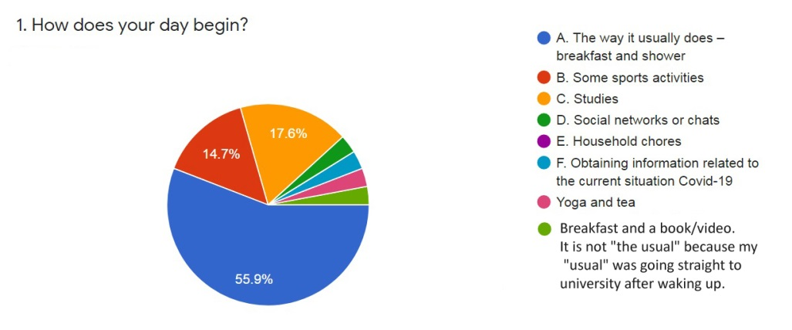

Figure 1. How does your day begin?

Due to the fact that the survey was carried out with students specializing in Medicine and Dental Medicine, 85.3% try to be informed relevantly of Covid-19 situation (Question 2). Those who pay attention only to statistics are 8.8%; 2.9% are involved in how the other countries handle the situation and 2.9% are only interested in the manifestations of virus clinical picture and necessary precautions. The answer “Prefer not to be informed” was not among chosen. Figure 2 points out the obtained results.

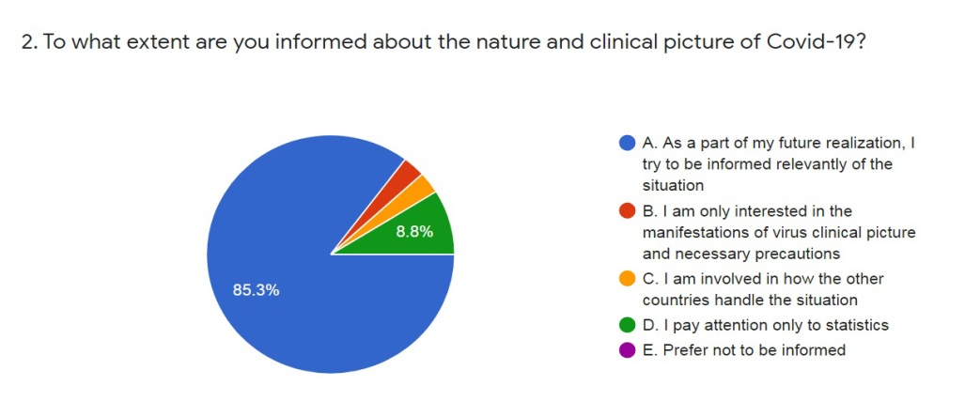

Figure 2.To what extent are you informed about the nature and clinical picture of Covid-19?

The third question from the survey concerns the sustainability of respondents' psyche and change in their anxiety exponential curve from the first day of quarantine. 32.4% showed they became a bit more anxious; 26.5% answered their anxiety curve stays on the same level; 20.6% - became more relaxed with time; 17.6% - feel psychologically stable and in only 2.9% of the students the exponential anxiety curve dramatically increased compared to the onset of quarantine. The data can be seen on Figure 3.

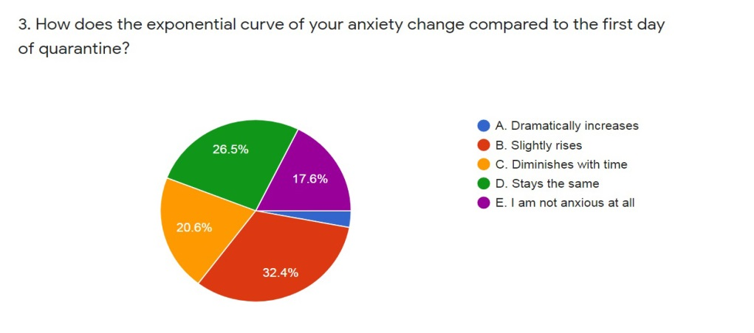

Figure 3. How does the exponential curve of your anxiety change compared to the first day of quarantine?
Regarding some alterations (Question 4), which the respondents have already observed in themselves, in terms of value system, social empathy, psychological balance, 52.9% replied positively. They saw some changes to some degree. Others (20.6%) were more emphatic; 17.6% were not certain and 8.8% have not noticed any alterations in themselves so far. The results are shown on Figure 4.
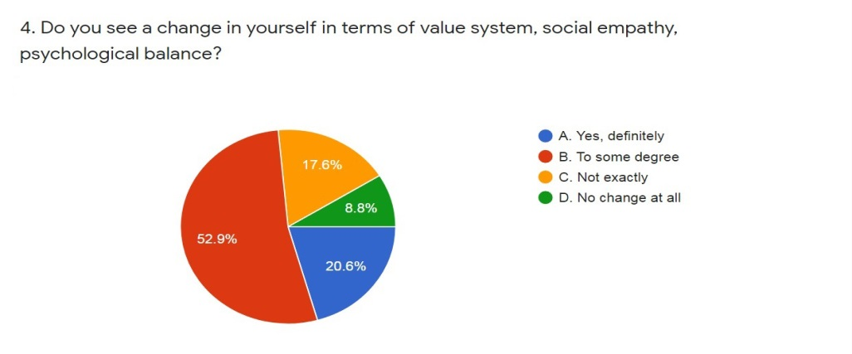

Figure 4. Do you see a change in yourself in terms of value system, social empathy, psychological balance?
The respondents' answers to question 5 clearly demonstrate their contribution to controlling the pandemic Covid-19. 91.2% firmly claimed that they keep safety measures strictly. Some of the students are still or have been volunteers (2.9%); others worked as a nurse (2.9%) and 2.9% think that “the measures were okay until now, but at some point we will have to be allowed to return to our normal lives. The virus is not going to vanish from the atmosphere, so there is no point of us keep staying at home like "forever”. The obtained data is presented on Figure 5.

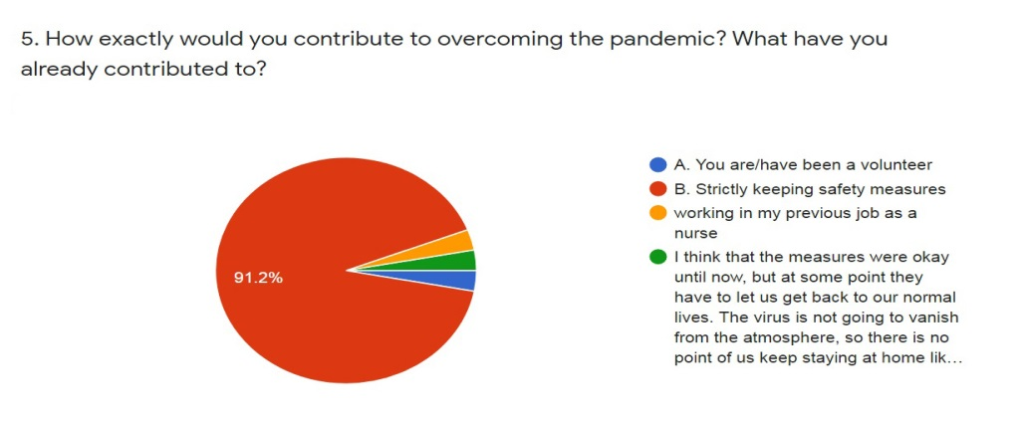

Figure 5. How exactly would you contribute to overcoming the pandemic? What have you already contributed to?

Question 6 of the survey is open and concerns the rearrangement of students' moral values to date, in accordance with Covid-19 emergence state. The outcomes are as follows (starting with the value that matters most to all respondents):
- Health - psychological and physical (of me, my family and friends)
- Family, love (take care of the people that you love)
- Lives of others (solidarity, support, loyalty)
- Keeping the quarantine as long as possible to avoid a new wave of Covid -19 (self-discipline, strict social distancing, personal precautions, keeping high hygiene)
- Studies (education, personal development)
- Patience, positivity, staying calm and consistent
- Social life and contacts
In relation to strictly observing personal, social and virtual hygiene (Question 7) the respondents gave a very definite answer – 94.1% keep all types of hygiene uncompromisingly. Others observe only personal hygiene (2.9%) or both social and personal hygiene (2.9%), as well. Figure 6 indicates the obtained data.

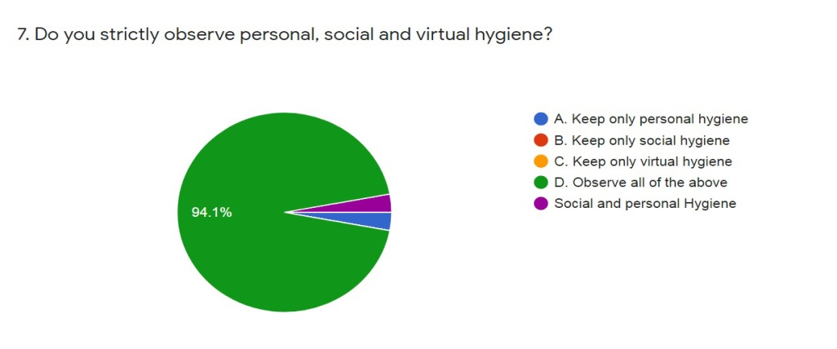

Figure 6. Do you strictly observe personal, social and virtual hygiene?

Physical activities and ways to keep fit during quarantine are presented in question 8. Concerning the students’ responses – 61.8% do physical exercises which do not require special equipment, 17.6% walk or go jogging outside, 14.7% do not perform any physical activities, 2.9% - do any inside sports – table tennis, darts, basketball, squash, rope jumping and 2.9% - prefer yoga and meditation. The data is presented on Figure 7.

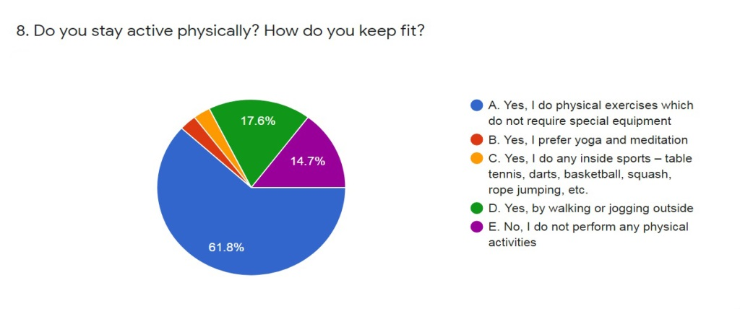

Figure 7. Do you stay active physically? How do you keep fit?

Question 9 of the conducted study shows students' preferences for certain foods during a state of emergency. It is noteworthy that the most popular answer is again quite empathic in favor of combination of all the foods mentioned in question (73.5%). 17.6% consume mainly protein-rich food and 8.8% - rich in carbohydrates. The results can be seen on Figure 8.

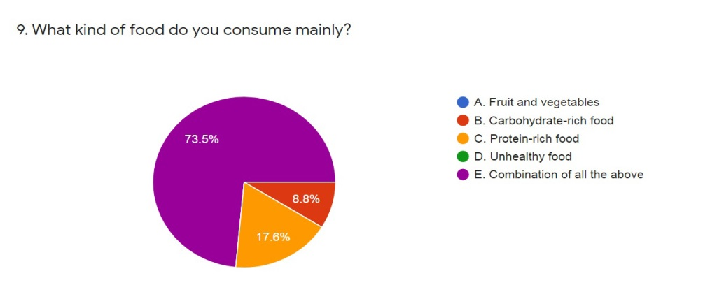

Figure 8. What kind of food do you consume mainly?

A greater variety of answers was received to question 10 about the amount of food consumed daily. Half of the respondents try to eat healthily consuming variety of foods (50%), 23.5% mark a slight increase in amount of some foods, 14.7% do not see a change in their diet amount, 5.9% definitely increased amount of most foods and the same percentage of respondents (5.9%) definitely decreased amount of most foods. Figure 9 points out the obtained results.

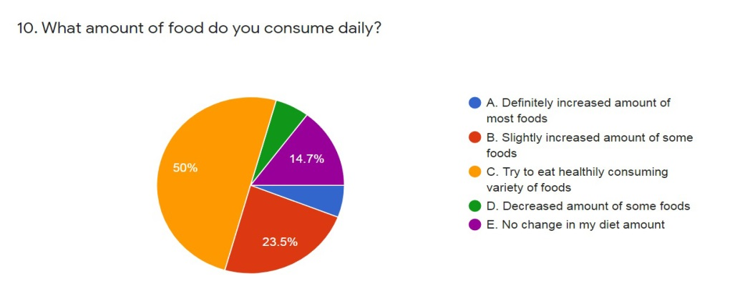

Figure 9. What amount of food do you consume daily?

Question 11 is similar to the previous one. It refers to the amount of liquids consumed daily during the state of emergency. There is a definite answer, as well. 76.5% of the students try to consume 30 milliliters of body weight as usual (which is a generally accepted norm), 14.7% claim that they slightly decreased amount and 8.8% admit they do not consume enough liquids for their body weight. The data is shown on Figure 10.

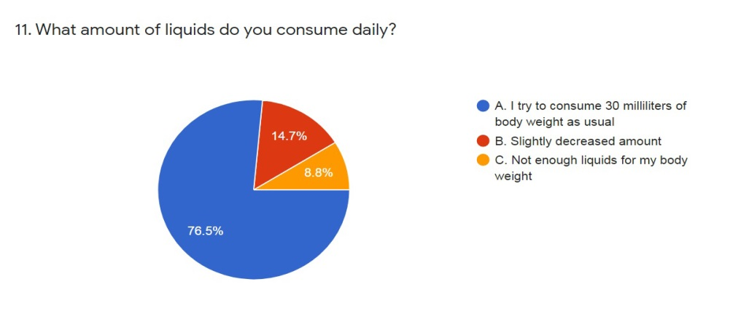

Figure 10. What amount of liquids do you consume daily?

In respect of some changes in respondents’ negative or positive habits, various responses were obtained (Question 12). Most of the students resumed reading books, painting or playing music (29.4%), 17.6% decreased the amount of some unhealthy food, 17.6% resumed cardio workouts, 17.6% do not observe any change, 14.7% decreased the amount of cigarettes and finally 2.9% resumed their yoga practical sessions. The results can be seen on Figure 11.

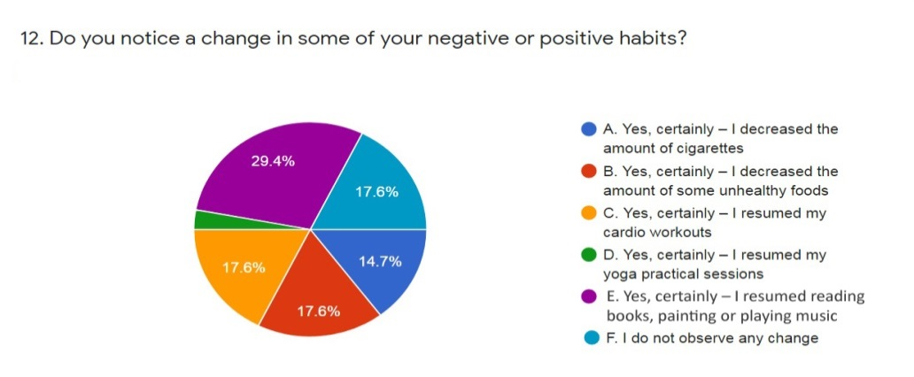

Figure 11. Do you notice a change in some of your negative or positive habits?
Question 13 about creating new hobbies or returning to old ones during quarantine provoked the following answers from the respondents. 47.1% created a new hobby, 38.2% resumed the old one and 14.7% simply do not have a hobby. Figure 12 indicates the obtained data.

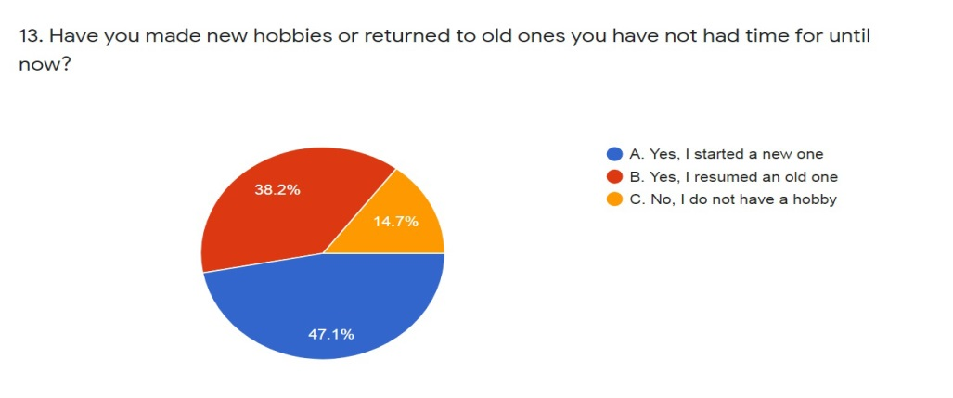

Figure 12. Have you made new hobbies or returned to old ones you have not had time for until now?

Solving the equation from the title "Covid-19"-((33%Stress+25%Panic+33% Ignorance+12%Negligence))/(3×(Responsibility+Self-discipline))=? undoubtedly initiated a variety of answers (Question 14). 44.1% supported the answer - revaluation of the value system, 26.5% - all of the above (revaluation of the value system, the only way out, a period of “probation”), 14.7% - the only way out, 11.8% - a period of “probation” and only 2.9% allege that this is just something we have and we will pass through. The outcomes are presented on Figure 13.
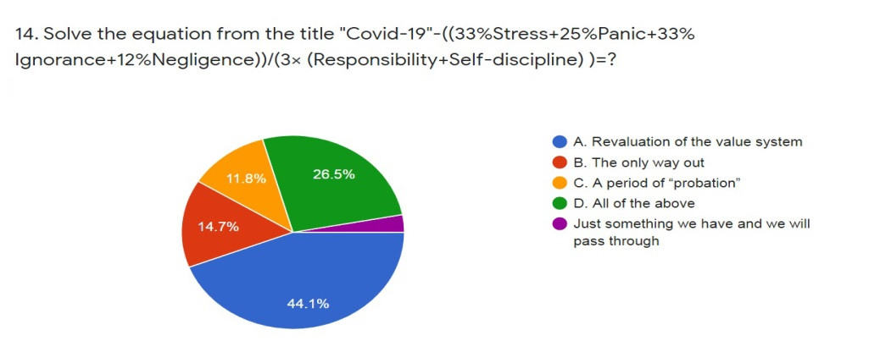

Figure 13. Solve the equation from the title "Covid-19"-((33%Stress+25%Panic+33% Ignorance+12%Negligence))/(3×(Responsibility+Self-discipline))=?

Obviously the last question (15) of the survey turned out to be the most intriguing for the students. They were asked to comment on Sir Winston Churchill's assertion “Never let a good crisis go to waste”. As predominant answer can be indicated the following – treat the situation adequately, learn the “lesson”, take advantage of the current state and convert all society weaknesses into strengths.
All data from the current survey was processed and it is statistically significant.
Discussion
Generally student surveys are certainly a valuable source of feedback for whole society and sciences, as they provide actionable insightful answers to a great number of current issues. The results obtained and the conclusions drawn can even modify effectively a new approach, a new view on various subjects. Furthermore, in present force majeure circumstances, adults are not the most appropriate target group for such a study - we mean at a purely physiological level (age, accompanying diseases) and regarding mentality (stress, fear). This explains our decision to conduct such a survey and address young people of different nationalities in order to create a realistic behavioral model during pandemic (Covid-19).
It is generally accepted that health is a state of complete physical, mental, sexual and social well-being and the ability of man to adapt to the ever-changing conditions of external and internal environment and natural aging process, as well as the absence of disease and physical defects (Chernosvitov, 2000; Kokhan, Pateyuk, Krivosheyeva et al., 2015; Vasilenko, 2004). Health is also defined as a property of man to perform his biosocial functions in a changing environment with loads and without losses (Kokhan, Serdtsev, & Romanova, 2009). And when the organism goes beyond its usual framework of existence and development, change is needed. Change at every level, including physical, psychological and moral (Filippov & Filippova, 2003; Lisitsyn & Ulumbekova, 2015; Sallis & Owen, 2012; Yushchuk, Mayev & Gurevich, 2012).
The balance between a stable psyche, reasonable eating habits and regular physical activities is the key to the outcome of the current pandemic situation.
Health today is largely in a well-structured psyche. We are living in an unusual “atmosphere”. The Earth is “contaminated” by Coronavirus (Covid-19) and the scale and consequences of what we are facing now are far from clear. As human beings, we naturally tend to experience fear. We start asking ourselves many questions. How to overcome our fears and not let the feeling of anxiety and panic engulf us? How to harness the latent power of our minds to minimize damage, especially now when so many fears are growing? Can we overcome these fears? Can we save ourselves and how to preserve our psyche? The moment everyday life has shifted, the whole unit of psychological pressure, panic and stress became very active. We are currently experiencing uncertainty of how the future might unfold (Green, Meagher & Millon, 1982; Igumnov & Zhebentyayev, 2011; Tashkova, 2020). Consequently, the creation of Covid-19 behavioral model in both psychological and moral aspects at present is of paramount importance - firstly, as a powerful resistance to the uncontrollable dynamics, with which the pandemic is developing, and secondly, as something extremely necessary to teach ourselves and our children - adaptation to change.
Based on the survey conducted with students from MU - Sofia, the following effective strategies have been determined on how to take care of our mental and moral health during a pandemic:
- Keeping overall lifestyle with slight changes in the priority activities at the beginning of the working day turns out to be a serious adaptive mechanism. University studies and keeping fit are among the priority changes for the respondents after the traditional breakfast and shower. Definitely, such a priority list gives students a safe and sufficiently focused start of the day.
- Paying attention to activities that create pleasant emotions and a positive attitude towards life; reducing the intensity of bad habits and increasing the intensity of positive ones.
- Awareness of the situation and treating it adequately and not allowing the feeling of anxiety and panic to increase. Staying mentally stable and balanced.
- High level of social empathy - empathy for the emerging social problem – by means of staying relevantly informed of Covid-19, strict compliance with imposed safety measures - social isolation; hygiene (personal, social and virtual); personal contribution to overcoming the pandemic (working as a volunteer or a nurse); staying in solidarity with society, showing support and loyalty and taking care of other people’s life.
- Positive attitude towards the outcome of current pandemic scenario and control of dynamic speed with which the coronavirus is developing today.
- Not facing a big crisis passively, learning from every experience and benefit in order to act differently in future.
- Reflect on what is really important, on true values of life that people sometimes ignore, taken by a thousand worries.
- Reassessment of the existing value system, prioritizing family relationships. Defining family as a value compared to a previous survey, where the family relationships are not indicated at all (Taneva, 2019).
- Reevaluate, improve and change to better in terms of every individual and society as a whole, and in any dimension – personal, social, systematical, etc.

While pressure and panic are beginning to define us in today’s Covid-19 scenario, while we are seeking the most powerful “antidepressant” and the best way to “de-capsulate” ourselves from this reality, while we are trying to resolve this great social trauma for all of us, the need arises to build an effective strategy to preserve our physical health. Food quality and sports activities, and related established habits are an integral component of an individual's physical health.
Environmentally friendly lifestyle, including mostly healthy diet (product selection, regimen) and physical activity, is proven to be increasingly significant in the dynamics of these days. In the current pandemic situation, it becomes even more relevant. A number of authors focus on the fact that according to the latest scientific database, there are many products that have an adverse effect on the human organism as a whole. They make recommendations about reducing certain foods that suppress immunity, or even stopping their consumption (Kovacheva, 2016; Taneva, 2019.). Some of the researchers pay attention to the right combination of foods, identifying as a basic rule non-mixing of proteins with carbohydrates, possibility to combine them with vegetables and fruit intake alone (Kovacheva, 2017; Pogozheva, 2016; Shelton, 1951, 1996; Taneva, 2019). Besides, physical activity and sports are highly assessed as one of the priority units of a healthy lifestyle (Bozhkova, 2012; Bozhkova & Slavcheva, 2012; Tsankova, 2013). It is also considered that their proper combination with good nutrition habits would contribute to the adaptation of our organism to any alteration (Bozhkova, Slavcheva-Hinkova & Lekina, 2017) Therefore, increasing the protection of such positive factors – rational nutrition and physical activity - would prove to be an effective move in the defense of human body against Covid-19 pandemic.
In modern society, young people, being more mature and independent, are increasingly making their conscious choice to live healthily. In the present survey, carried out among 112 students, aged 19-25, from different countries (Greece, Germany, Italy, England, Cyprus and Japan) studying medicine and dentistry at the Medical University, Sofia, Bulgaria, it became clear that the respondents are well aware that physical health is largely rooted in an environmentally balanced diet and regular physical activity. They realize that providing a varied diet, specific proteins that are the basis of humoral immunity and are a building block of antibodies so necessary for the body now, is definitely a building strategy to date. In addition, the students indicate the extreme importance of physical activity to maintain good health status and view it as a valuable long-term effect on our health and life. Physical exercises are an integral part of their daily lives currently.
In this regard, the following baselines for Covid-19 behaviour can be outlined:
- Consumption of nutritious food, which means varied (protein-rich food, carbohydrate-rich food, fruit and vegetables).
- Ensuring the intake of sufficient quality protein food.
- Emphasis in nutrition on fruit and vegetables.
- Intake of a moderate amount of food.
- Liquid intake according to the generally accepted norm.
- Keeping fit by means of doing regular physical exercises.
The right combination of all effective strategies for outlining a behavioral model during pandemic (Covid-19) would lead to maintaining a good health status and creating an optimistic attitude to the final outcome of the situation.
Conclusions
Scenarios are constantly being created in the dynamics of modern being and consciousness - a screenplay for a movie, a libretto for an opera or ballet, a plot for a novel or a picture, where the main “protagonists” are always Life and Man. And if these two so complex machines, interacting, are in constant symbiosis and equilibrium, they will undoubtedly overcome all hardships, even in such pandemic circumstances. They will create the best “scenario” for a constructive behavioral model Covid-19. A model with responsibility for physical, psychological, social and moral health.
Acknowledgement
The current study would not have been possible without the ongoing participation of Bulgarian and foreign students, being taught in specialties Medicine and Dental Medicine at the Medical University – Sofia, Bulgaria. The author is grateful to all students, willing to participate in the survey.

Библиографический список:
- Василенко Н. Ю. Основы социальной медицины. Владивосток: Дальневосточный университет, 2004. С. 9-12.

- Игумнов С.А., Жебентяев В.А. Стресс и стресс-зависимые заболевания. СПб.: Речь, 2011. 345 с.

- Кохан С.Т., Патеюк А.В., Кривошеева E.M. и др. Основы здорого образа жизни: учебное пособие / 2-е изд. Чита: ЗабГУ, 2015.186с.

- Кохан С. Т., Сердцев М.И., & Романова И.В. Региональные компоненты формирования здорового образа жизни среди студенческой молодежи: учеб. пособие. Чита: ЧитГУ, 2009. 198 с.

- Лисицын Ю.П., Улумбекова Г. Э.Общественное здоровье и здравоохранение: учебник / 3-е изд., перераб. и доп. Москва: ГЭОТАР-Медиа, 2015. 544 с.

- Погожева А. Вкусная и здоровая пища. Как научится сочетать? Москва: Эксмо, 2016.

- Филиппов П.И., Филиппова В.П. Гигиеническое воспитание и формирование здорового образа жизни. Москва: ВУНМЦ, 2003. 288 с.

- Черносвитов Е. В. Социальная Медицина. Учебное пособие для Вузов. Москва: Гуманитарный центр ВЛАДОС и Московский Государственный Социальный Университет, 2000. С.40-45.

- Ющук Н.Д., Маев И.В., & Гуревич К.Г. Здоровый образ жизни и профилактика заболеваний. Москва: Перо, 2012. С.207-222

- Божкова А. Професионално ориентирана двигателна подготовка за студенти от специалност Медицински рехабилитатор, ерготерапевт. София: АРТГРАФ. ISBN 978-954-9401-73-8, 2012. 126с.

- Божкова А., Славчева П. Комбинирана фитнес гимнастика. Ръководство за студентки по дентална медицина. София: AРТГРАФ. ISBN 978-954-9401-72-1, 2012. 94с.

- Ковачева Л. Дишане, хранене, здраве.Непубликувани размисли. София: Кибеа, ISBN: 954-474-786-2, 2017. 160с.

- Ковачева Л. Дълголетието. По стъпките на Хипократ. София: Гуторанов и син, 2016. С.25

- Ташкова, Р. Как се отразява пандемията на психиката ни и как да се погрижим за нея. //Сп. Българска наука, Април, 2020, С. 56-59.
- URL:https://image.nauka.bg/magazine/BG-Nauka-COVID-19.pdf

- Цанкова Ж. Т. Методика за обучение по баскетбол във висшите училища : монография. София: Найс Ан, 2013. 128 с.

- Bozhkova А., Slavcheva-Hinkova P., & Lekina D. Impact of specialized sports program for students with health issues. Journal of Physical Education and Sport (JPES), Vol. 17 Supplement issue 1, Art 1, online ISSN: 2247 - 806X; p-ISSN: 2247 - 8051; ISSN - L = 2247 - 8051, 2017. pp. 3-6.

- Green C., Meagher R., & Millon T. Handbook of clinical health psychology New York: Plenum Press, Springer US. 1982. eBook ISBN: 978-1-4613-3412-5. 632p.

- Sallis J.F., Owen N. Physical activity and behavioral medicine. SAGE Publications, Inc. Online Publication Date: May 31, 2012. ISBN: 9781452233765.

- Shelton H. M. Food combining made easy. San Antonio, USA: Dr. Shelton’s health school,1951.

- Shelton H. M. History of Natural Hygiene and Principles of Natural Hygiene. Whitefish, USA: Kessinger Publishing, 1996.

- Taneva, S. Hygiene of nutrition as a first-rate value of healthy way of life. //X International scientific-practical online conference. / ed. S.Т. Kokhan. - Chita, ISBN: 978-5-9293-1883-2, 2019. pp. 218-226.

References
- Vasilenko N. YU. (2004). Osnovy sotsial'noy meditsiny [Fundamentals of social medicine]. Vladivostok: Dal'nevostochnyy universitet, pp 9-12.(in Russian).

- Igumnov S.A., & Zhebentyayev V.A. (2011). Stress i stress-zavisimyye zabolevaniya [Stress and stress-related diseases]. St. Petersburg: Rech',. 345 p.(in Russian).

- Kokhan S.T., Pateyuk A.V., Krivosheyeva E.M. et al. (2015). Osnovy zdorogo obraza zhizni: uchebnoye posobiye / 2-ye izd [Fundamentals of a healthy lifestyle]. Chita: ZabGU, 186p. (in Russian).

- Kokhan S. T., Serdtsev M.I., & Romanova I.V. (2009). Regional'nyye komponenty formirovaniya zdorovogo obraza zhizni sredi studencheskoy molodezhi: ucheb. posobiye [Regional components of the formation of a healthy lifestyle among students]. Chita: ChitGU, 198p. (in Russian).

- Lisitsyn YU.P., & Ulumbekova G. E. (2015). Obshchestvennoye zdorov'ye i zdravookhraneniye: uchebnik / 3-ye izd., pererab. i dop.[ Public health and healthcare]. Moscow: GEOTAR-Media, 544p. (in Russian).

- Pogozheva A. (2016). Vkusnaya i zdorovaya pishcha. Kak nauchitsya sochetat'? [Tasty and healthy food. How to learn to combine?]. Moscow: Eksmo. (in Russian).

- Filippov P.I., & Filippova V.P. (2003). Gigiyenicheskoye vospitaniye i formirovaniye zdorovogo obraza zhizni [Hygienic education and the formation of a healthy lifestyle]. Moscow: VUNMTS, 288p. (in Russian).

- Chernosvitov Ye. V. (2000). Sotsial'naya Meditsina [Social Medicine]. Uchebnoye posobiye dlya Vuzov. Moscow: Gumanitarnyy tsentr VLADOS i Moskovskiy Gosudarstvennyy Sotsial'nyy Universitet, pp.40-45. (in Russian).

- Yushchuk N.D., Mayev I.V., & Gurevich K.G. (2012). Zdorovyy obraz zhizni i profilaktika zabolevaniy [Healthy lifestyle and disease prevention]. Moscow: Pero, pp.207-222. (in Russian).

- Bozhkova A. (2012). Profesionalno orientirana dvigatelna podgotovka za studenti ot spetsialnost Meditsinski rekhabilitator, ergoterapevt [Professional oriented motor preparation for students in the specialty Medical Rehabilitation Therapy and Ergotherapy]. Sofia: ARTGRAF. ISBN 978-954-9401-73-8, 126p. (in Bulgarian).

- Bozhkova A., & Slavcheva P. (2012). Kombinirana fitnes gimnastika. Rŭkovodstvo za studentki po dentalna meditsina [Combined fitness gymnastics. Dental Medicine Students’ Tutorial]. Sofia: ARTGRAF. ISBN 978-954-9401-72-1, 94p. (in Bulgarian).

- Kovacheva L. (2017). Dishane, khranene, zdrave.Nepublikuvani razmisli [Breathing, Nutrition, Health - Unpublished Reflections]. Sofia: Kibea, ISBN: 954-474-786-2, 160p. (in Bulgarian).

- Kovacheva L. (2016). Dŭlgoletieto. Po stŭpkite na Khipokrat [Longevity. In the footsteps of Hippocrates]. Sofia: Gutoranov i sin, pp. 25. (in Bulgarian).

- Tashkova, R. (2020). Kak se otrazyava pandemiyata na psikhikata ni i kak da se pogrizhim za neya [How does the pandemic affect our psyche and how to take care of it]. //Sp. Bŭlgarska nauka, April, pp. 56-59. (in Bulgarian). URL:https://image.nauka.bg/magazine/BG-Nauka-COVID-19.pdf

- Tsankova Zh. T. (2013). Metodika za obuchenie po basketbol vŭv visshite uchilishta [Methodology for teaching basketball in higher schools: monograph]. Sofia: Naĭs An, 128 p. (in Bulgarian).

- Bozhkova А., Slavcheva-Hinkova P., & Lekina D. Impact of specialized sports program for students with health issues. Journal of Physical Education and Sport (JPES), Vol. 17 Supplement issue 1, Art 1, online ISSN: 2247 - 806X; p-ISSN: 2247 - 8051; ISSN - L = 2247 - 8051, 2017. pp. 3-6.

- Green C., Meagher R., & Millon T. Handbook of clinical health psychology New York: Plenum Press, Springer US. 1982. eBook ISBN: 978-1-4613-3412-5. 632p.

- Sallis J.F., Owen N. Physical activity and behavioral medicine. SAGE Publications, Inc. Online Publication Date: May 31, 2012. ISBN: 9781452233765.

- Shelton H. M. Food combining made easy. San Antonio, USA: Dr. Shelton’s health school, 1951.

- Shelton H. M. History of Natural Hygiene and Principles of Natural Hygiene. Whitefish, USA: Kessinger Publishing, 1996.

- Taneva, S. Hygiene of nutrition as a first-rate value of healthy way of life. //X International scientific-practical online conference. / ed. S.Т. Kokhan. - Chita, ISBN: 978-5-9293-1883-2, 2019. pp. 218-226.

Вклад авторов:
A – Разработка концепции или дизайн методологии; создание моделей, изучение проблемы
B – Применение статистических, математических, вычислительных или других исследований
C – Проведение исследований, в частности проведение экспериментов или сбор данных
D – Подготовка, создание и оформление рукописи

Authors ’Contribution:
A – Concept development or design methodology; creating models, studying the problem
B – Application of statistical, mathematical, computational or other studies
C – Research, in particular experimentation or data collection
D – Preparation, creation and design of the manuscript

